7) Write a python program to Illustrate Different Set Operations?

PROGRAM:
# Program to illustrate different Set Operations
# Creating sets
A = {1, 2, 3, 4, 5}
B = {4, 5, 6, 7}
print("Set A:", A)
print("Set B:", B)
# 1. Union
print("\nUnion (A | B):", A | B)
# 2. Intersection
print("Intersection (A & B):", A & B)
# 3. Difference
print("Difference (A - B):", A - B)
print("Difference (B - A):", B - A)
# 4. Symmetric Difference
print("Symmetric Difference (A ^ B):", A ^ B)
# 5. Membership Test
print("\nIs 3 in A?", 3 in A)
print("Is 10 not in B?", 10 not in B)
# 6. Add element
A.add(10)
print("\nAfter A.add(10):", A)
# 7. Remove element
A.remove(2)
print("After A.remove(2):", A)

OUTPUT:
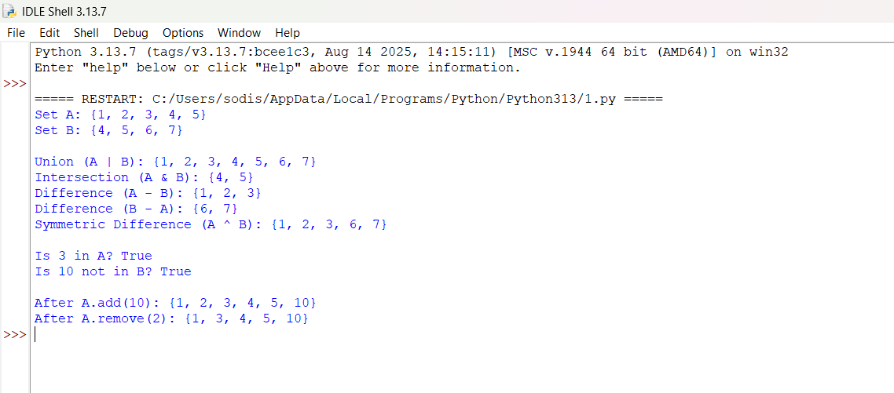

OUTPUT:
